Functional Requirements Document

CGTMSE - Online Application and Processing

**Process Name**: CGTMSE - Online Application and Processing

**Prepared by**: Novigo Solutions

**Date Prepared**: 25-05-2018

**Last Updated**: 25-05-2018

**Version**: 1.0

TABLE OF CONTENTS

1 DOCUMENT HISTORY 3

2 DOCUMENT RESOURCES 3

3 DOCUMENT APPROVALS 3

4 GLOSSARY OF TERMS 3

5 PROJECT SUMMARY 4

5.1.1 Background 4

5.1.2 Current Process Flow 4

5.1.3 Objectives 4

5.1.4 Projected Solution 5

6 FUNCTIONAL REQUIREMENTS 6

6.1.1 Prerequisites 6

6.1.2 Loan Application filling on CGTMSE system 7

6.1.3 Allocate & Initiate Payment 14

6.1.4 Perform NEFT/RTGS under CGTMSE 17

6.1.5 DAN Related Reports 17

7 EXCEPTIONS 18

8 Application Access Requirements 19

9 System Requirements 20

10 Appendix 21

11 OUT OF SCOPE 22

12 FUTURE SCOPE 22

13 ASSUMPTIONS 22

14 Risks & Mitigation 22

15 CLIENT ACCEPTANCE 23

# DOCUMENT HISTORY

|  |  |  |  |
| --- | --- | --- | --- |
| **Version** | **Description** | **Date** | **Author** |
| 1.0 | Initial Draft | 25-05-2018 | Linton Pereira |

# DOCUMENT RESOURCES

|  |  |
| --- | --- |
| **Name** | **Designation / Department** |
| Udayashankara C | Chief Manager, Credit Monitoring Dept – Settlement Cell |
| Shivshankar | Clerk, CGTMSE |
| Jagadeesh | Chief Manager, LAPS |

# DOCUMENT APPROVALS

|  |  |  |  |
| --- | --- | --- | --- |
| **Approver Name** | **Designation / Department** | **Signature** | **Date** |
| Divakara Rao | AGM, New Business Department |  |  |
| Udayashankara C | Chief Manager, Credit Monitoring Dept – Settlement Cell |  |  |

# GLOSSARY OF TERMS

The following table includes definitions for any abbreviations or notation ns that are used in the document:

|  |  |
| --- | --- |
| **Term** | **Definition** |
| RPA | Robotic Process Automation |
| CGTMSE | Credit Guarantee Fund Trust for Micro & Small Enterprises |
| LAPS | Loan Automation Processing System |
| TL | Term Loan |
| WC | Working Capital |
| HO | Head Office |
|  |  |
|  |  |

# PROJECT SUMMARY

### Background

Availability of bank credit without the hassles of collaterals/third party guarantees would be a major source of support to the first-generation entrepreneurs to realize their dream of setting up a unit of their own Micro and Small Enterprise (MSE). Keeping this objective in view, Ministry of Micro, Small & Medium Enterprises (MSME), Government of India launched Credit Guarantee Scheme (CGS) to strengthen credit delivery system and facilitate flow of credit to the MSE sector. To operationalize the scheme, Government of India and SIDBI set up the Credit Guarantee Fund Trust for Micro and Small Enterprises (CGTMSE). Loan up to 2 Cr can be sanctioned.

### Current Process Flow

CGTMSE process starts with the collection of loan application document from that comes under CGTMSE will be share by each branch to the Head office for filling the applications into CGTMSE system. This a daily operation approx. 30-40 applications per day. HO verifies all the application and confirms the data in Finacle or LAPS before entering into the system.

Loan application that comes for CGTMSE will be for Micro and Small, Manufacturing and service industry, for which CGTMSE loan will guarantee for Term Loan, Working Capital, both TL and WC, Enhancement of WC and renewal of WC. Maximum limit for TL and WC is 2 Crore.

Once the application is submitted, it will go for approval from CGTMSE Mumbai, which would take approx. 2 or more days to be approved. Once approved by CGTMSE Mumbai, CG PAN number will be generated and guaranty fee also gets generated. Then allocation of payment is done by allocating max of 50 CG PAN number and then submitted in the system there by generating a RP number (Payment id). This RP number (Payment id) is a group of CG PAN number which will be associated with a Virtual Account. Similarly continue allocation of payment for next set of CG PAN numbers. This activity is done once in a week or 2.

For a list of RP number, then payment is initiated and this is done and this by done my selecting the RP number and Click on next for Submission. Confirmation screen is displayed along with warning message saying RP will not be allowed to modify will be displayed. Click on OK the process is then completed and then an icon will be displayed to download the excel.

After this, RTGS needs to be performed from all the loan account to virtual account. Currently RTGS is done manually from HO Complex branch (Current account) to virtual account.

### Objectives

The overall objective of this project is to implement RPA for the CGTMSE Online Application and Processing in Credit - Monitoring Dept. - Settlement Cell. This will completely automate the manual task currently processed by the bank staff. The purpose of the proposed new system increases the productivity and makes the process error-free.

This process has been developed on UIPath RPA Automation Tool. And the proposed system will only work on top of Microsoft.Net framework.

### Projected Solution

The following items are marked as “In-Scope” for RPA Implementation:

* RPA shall directly pick the data from either LAPS or Finacle for filling of the application form for Term Loan(TL), Working Capital(WC), TL & WC, enhancement of WC, renewal of WC
* Any data that is not present either in LAPS or Finacle will be consolidated on an excel and place it in a local drive from which RPA can capture the data and fill the respective form.
* After Approval of application, allocated payment online and initiate payment.
* Perform NEFT/RTGS from loan account to virtual account via SLRTGS account

RPA shall collect the data from source application such as LAPS and Finacle and enter the same data in the CGTMSE system and submit the application, any data that in not currently present in the system shall be collected from the respective branches in an excel sheet (a generic format) which will be placed in the local drive in the system when robot in installed, then RPA shall pick the data from the excel sheet and enter in the CGTMSE system for respective application to submit.

Once the application is approved by CGTMSE Mumbai, RPA shall pick those application, check for CG PAN and then allocation of payment for first 50 CG PAN by clicking on the checkbox and next, checks if RP number (Payment id) is generated and then store this RP number (Payment id). Similarly continues allocation of payment for next 50 CG PAN.

RPA shall then initiate the payment for all the RP number (Payment id) generated. This is done by selecting RP numbers in Receipt – Payment page and clicking on Next. Make sure each RP number (Payment id) has virtual account created and amount displayed. This amount is the total some of loan amount that needs to be debited from each loan account associated with the CG PAN respectively. RPA shall capture all the data and save it in a common register (Excel sheet) which will be stored in a local file.

Finally, RPA shall perform NEFT/RTGS from loan account to virtual account. first perform a transfer of amount from individual loan account belonging to a RP number to SLRTGS account. this would debit the amount from loan account and credit to SLRTGS account. Once all the loan account amount is transferred to SLRTGS account perform NEFT/RTGS from SLRTGS account to Virtual account, this would debit the amount from SLRTGS and credit the amount to virtual account.

RPA shall then send DAN related reports about each loan account to their respective branches individually via email.

# FUNCTIONAL REQUIREMENTS

### Prerequisites

| **Req#** | **Function** | **Description** | **Priority** | **Reference/Comments** |
| --- | --- | --- | --- | --- |
| FR-P-001 | Capturing Loan Accounts | RPA shall capture list of sanctioned loan account numbers which are marked under CGTMSE from LAPS. | High |  |
| FR-P-002 | Capturing Loan Accounts | Any data not present in LAPS, RPA shall be picked from the excel sheet sent by each branch which will be placed in a local drive | High |  |
| FR-P-003 | Capturing Loan Accounts | RPA shall capture of the following from LAPS for loan type   1. Term loan 2. Working capital 3. Both TL & WC 4. Enhancement of WC 5. Renewal of WC | High |  |
| FR-P-004 | Capturing Loan Accounts | RPA shall capture of the following from LAPS for MSE classification   1. Small enterprise 2. Micro enterprise | High |  |
| FR-P-005 | Capturing Loan Accounts | RPA shall capture of the following from LAPS for Nature of industry   1. Manufacturing 2. Service | High |  |
| FR-P-006 | Capturing Loan Accounts | RPA shall check if the Term loan applied is fresh or existing | High |  |
| FR-P-007 | Capturing Loan Accounts | RPA shall check if the Term loan applied is fresh or existing for TL and both TL & WC loan applications. | High |  |
| FR-P-008 | Capturing Loan Accounts | For existing term loan applying for new term loan again, RPA shall capture CP PAN number for existing TL | High | This information shall be made available in LAPS, else shall be stored in Local drive against loan application |
| FR-P-009 | Capturing Loan Accounts | RPA shall check and capture of the following from WC, both TL & WC for loan type   1. Fund based 2. Non- Fund based 3. Both | High |  |
| FR-P-010 | Capturing Loan Accounts | RPA shall check in LAP is the chief promoter belongs to minority community | High |  |
| FR-P-011 | Capturing Loan Accounts | RPA shall check in LAP whether the unit assisted in women operated and/or women owned | High |  |
| FR-P-012 | Capturing Loan Accounts | RPA shall check in LAPS if the constitution.  If constitution = Proprietor/individual  Then Promoter details shall be self-details or company  else constitution = partnership or others  Then Promoter details shall be main director and other partner or promoter directors need to be filled which is mandatory | High |  |

### Loan Application filling on CGTMSE system

Below is the list of application filled in the CGTMSE system

1. Term loan

2. Working capital

3. Both TL & WC

4. Enhancement of WC

5. Renewal of WC

#### CGTMSE Login

* Login to CGTMSE using URL <https://inter.cgtmse.in/showLogin.do>.
* Enter the **Member id**, **User id** and **password**. Click on **Login**. The login screen is as shown in figure 6.2.1-1

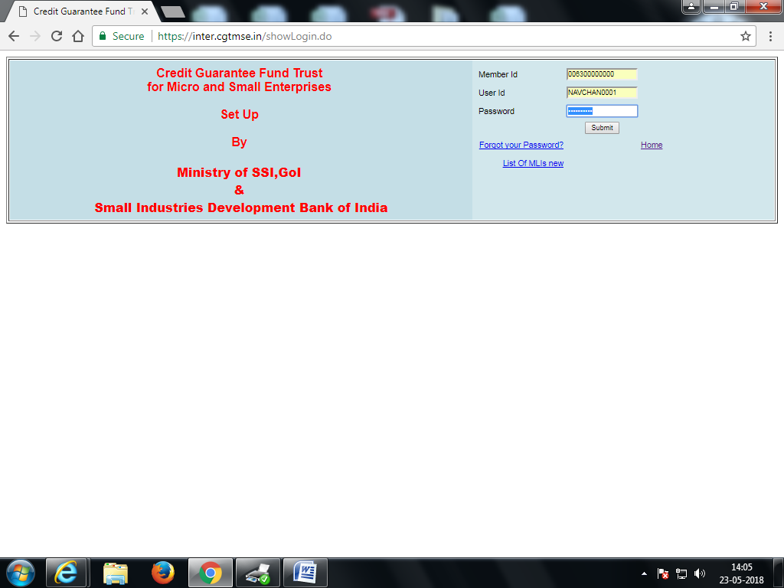

Figure 6.1.2‑1 : CGTMSE Login Screen

#### Online Application

* After login in to the system, navigate Application processing > Guarantee for > [Loan type]. The navigation is as shown in figure 6.2.1-2

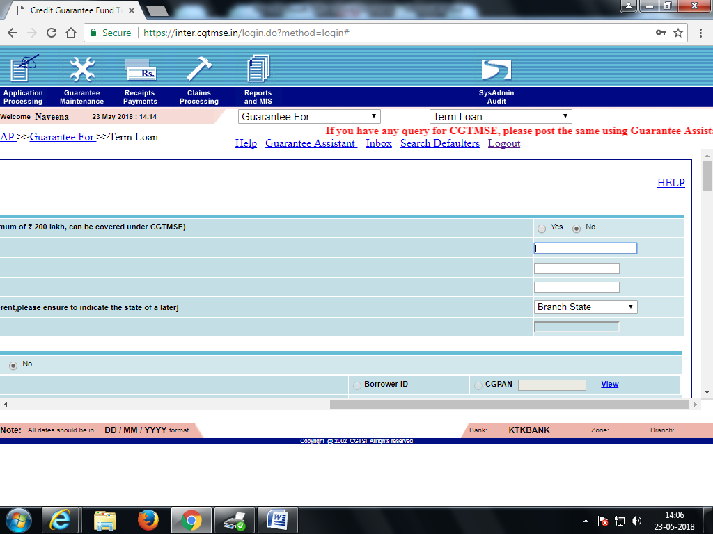

Figure 6.1.2‑2: Inward Details – Taxable Screen

| **Req#** | **Function** | **Description** | **Priority** | **Reference/Comments** |
| --- | --- | --- | --- | --- |
| FR-OA-001 | Online Application | RPA shall fill all Loan type application in Capital letters in CGTMSE site | High |  |
| FR-OA-002 | Online Application | RPA shall make sure to fill in all the mandatory data for respective application | High | Refer Appendix Req# 1 |
| FR-OA-003 | Online Application | RPA shall enter the date in DD/MM/YYYY format | High |  |
| FR-OA-004 | Online Application | Last Name is mandatory, if Last name is not present RPA shall enter dot ‘.’ | High |  |
| FR-OA-005 | Online Application | RPA shall make sure CG PAN is not present for Fresh Term Loan | High | To check the application status, refer Appendix Req# 9 |
| FR-OA-006 | Online Application | RPA shall make sure CG PAN is in approved status for existing Term Loan | High | To check the application status, refer Appendix Req# 9 |
| FR-OA-007 | Online Application | RPA shall enter as Fresh term loan is the CG PAN is in expired status | High | To check the application status, refer Appendix Req# 9 |
| FR-OA-008 | Online Application | RPA shall fill the fresh application for Term loan for Micro Manufacturing as mention in the document | High | Refer Appendix Req# 4 |
| FR-OA-009 | Online Application | RPA shall fill the fresh application for Term loan for Small Manufacturing as mention in the document | High | Refer Appendix Req# 4 |
| FR-OA-010 | Online Application | RPA shall fill the fresh application for Term loan for Micro Service as mention in the document | High | Refer Appendix Req# 4 |
| FR-OA-011 | Online Application | RPA shall fill the fresh application for Term loan for Small service as mention in the document | High | Refer Appendix Req# 4 |
| FR-OA-012 | Online Application | RPA shall fill the existing application for Term loan by entering CG PAN and then clicking on View  Existing term loan also supports the below   1. Micro Manufacturing 2. Small Manufacturing 3. Micro Services 4. Small Services | High | Refer Appendix Req# 5 |
| FR-OA-013 | Online Application | RPA shall fill the application for Working capital as mention in the document  WC also supports the below   1. Micro Manufacturing 2. Small Manufacturing 3. Micro Services 4. Small Services   Along with   1. Fund based 2. Non- fund based 3. Both | High | Refer Appendix Req# 6 |
| FR-OA-014 | Online Application | RPA shall fill the application for both term loan & Working capital as mention in the document  Both TC & WC also supports the below   1. Micro Manufacturing 2. Small Manufacturing 3. Micro Services 4. Small Services   Along with   1. Fund based 2. Non- fund based 3. Both | High | Refer Appendix Req# 4 & Req# 6 |
| FR-OA-015 | Online Application | RPA shall fill the existing application for Term loan and WC by entering CG PAN and then clicking on View  Both TC & WC also supports the below   1. Micro Manufacturing 2. Small Manufacturing 3. Micro Services 4. Small Services   Along with   1. Fund based 2. Non- fund based 3. Both |  | Refer Appendix Req# 5 & Req# 6 |
| FR-OA-016 | Online Application | RPA shall calculate MCLR base rate = (Contr Int. Rate -A/c pref. Int.(Dr.) which is present in Finacle | High |  |
| FR-OA-017 | Online Application | After submission of TL, WC and both TL and WC, a reference number is generated by CTGMSE application, RPA shall store this ref no for future use. | High |  |
| FR-OA-018 | Online Application | If any data is not filled or entered incorrectly, CGTMSE system will display appropriate error message, RPA shall understand the error message and fill in the correct data. | High |  |
| FR-OA-019 | Online Application | RPA shall fill the enhancement of WC application by entering CG PAN and then clicking on OK | High | Refer Appendix Req# 7 |
| FR-OA-020 | Online Application | RPA shall enter the enhance amount for the respective WC and then verify the field Enhance fund based (existing + new) | High |  |
| FR-OA-021 | Online Application | RPA shall verify on enhancement of WC is submitted “Enhancement of Working Capital completed successfully” is displayed | High |  |
| FR-OA-022 | Online Application | For renewal of working capital RPA shall first check the status of CG PAN number which should be expired. | High | Refer Appendix Req# 8 |
| FR-OA-023 | Online Application | RPA can renew the WC, one day after expiration | High |  |
| FR-OA-024 | Online Application | RPA shall fill the renewal of WC application by entering CG PAN and then clicking on OK | High | Refer Appendix Req# 8 |
| FR-OA-025 | Online Application | RPA shall make sure the amount is not changed for renewal of WC | High |  |
| FR-OA-026 | Online Application | RPA shall make sure the date of renewal is entered for renewal of WC | High |  |
| FR-OA-027 | Online Application | RPA shall make sure the interest type is always made as Floating | High |  |
| FR-OA-028 | Online Application | After submission of renewal of WC, a reference number is generated by CTGMSE application, RPA shall store this ref no for future use. | High |  |

#### Loan Application - Status Check

* Once all the loan application is submitted on the CGTMSE system, can be checked by navigating Reports & MIS > Application details > Status Wise. The navigation is as shown in figure 6.2.3-1

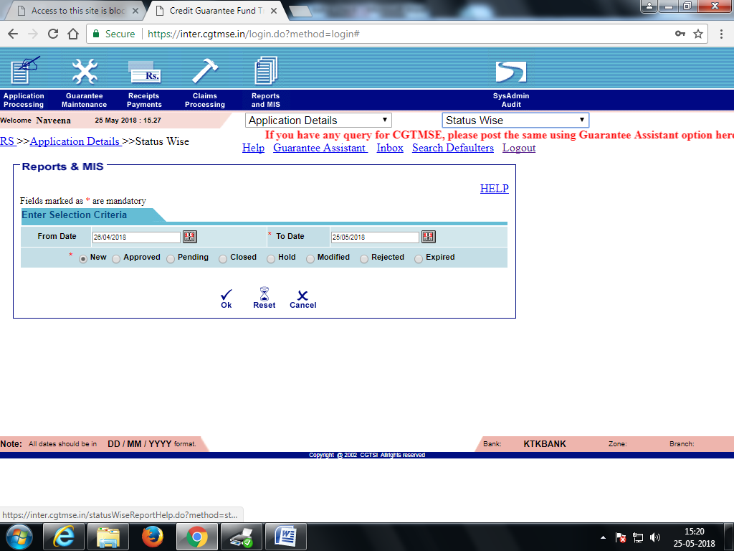

Figure 6.1.2‑2 : CGTMSE Reports & MIS

* Following application status can be checked,
  1. New
  2. Approved
  3. Pending
  4. Closed
  5. Hold
  6. Modified
  7. Rejected
  8. Expired
* Any application that’s been submitted can be found in New
* All the approved application by CGTMSE Mumbai shall be displayed with a status as AP for the selected date range. As shown in figure 6.2.3-2

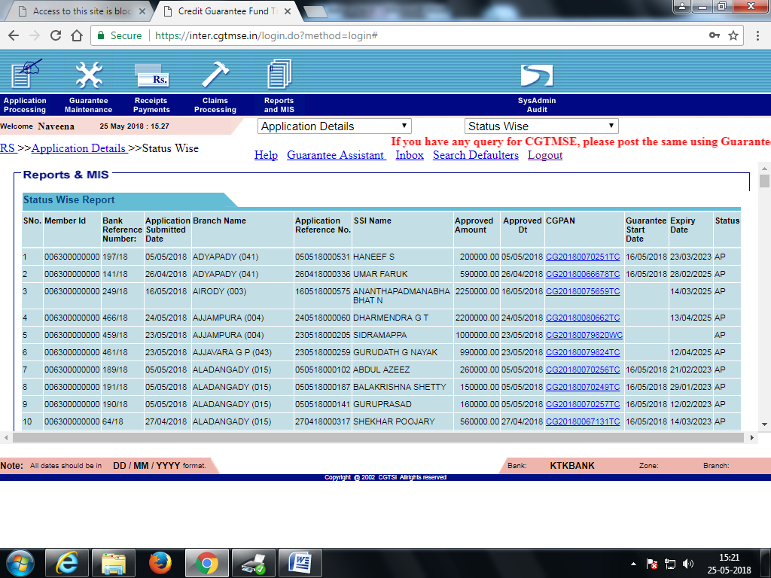

Figure 6.1.2‑3 : CGTMSE Reports & MIS

### Allocate & Initiate Payment

Allocation and initiate payment for all the load application submitted on CGTMSE system can be done only after CGTMSE has approved via GF Payment through NEFT/RTGS

#### Allocate Payment Online

* Navigation: Receipt Payments > GF Payment through NEFT/RTGS > Allocate Payment Online. As shown in figure 6.1.3‑1

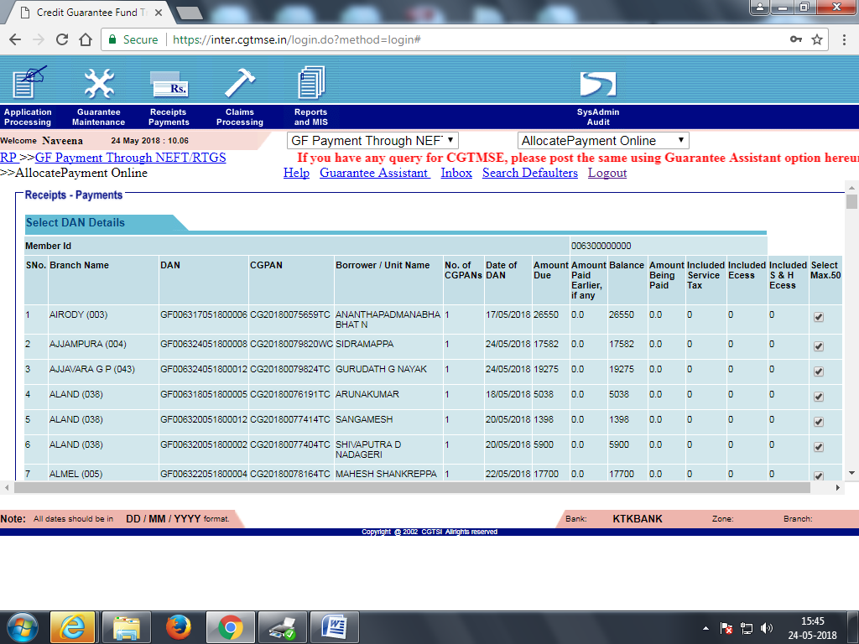

Figure 6.1.3‑2 : Allocate Payment Online

#### Initiate Payment

* Once the allocation is completed, RP number (Payment id) will get generated for the group of 50 loan accounts
* Navigate: Receipt Payments > GF Payment through NEFT/RTGS >Initiate Payment. As shown in

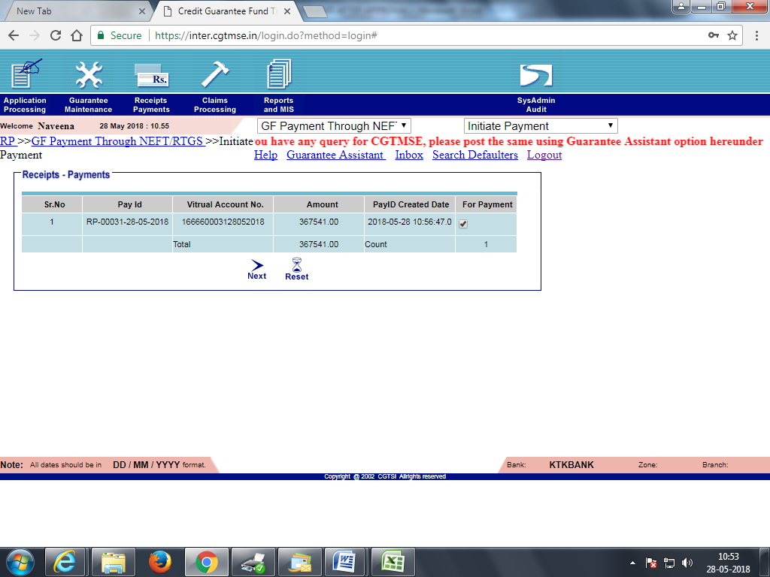

Figure 6.1.3‑2: Initiate Payment

| **Req#** | **Function** | **Description** | **Priority** | **Reference/Comments** |
| --- | --- | --- | --- | --- |
| FR-AI-001 | Allocate Payment Online | RPA shall pick the first 50 application for allocation payment online by checking the checkbox  (Max of 50 application can be selected) | High | Refer Appendix Req# 10  (excluding duplicates) |
| FR-AI-002 | Allocate Payment Online | RPA shall verify amount due against each CG PAN or Loan account either in Finacle or LAPS | High |  |
| FR-AI-003 | Allocate Payment Online | RPA shall verify the total count displayed after selected 50 applications | High |  |
| FR-AI-004 | Allocate Payment Online | RPA shall verify the amount displayed in total which is the sum of due amount after selected 50 applications | High |  |
| FR-AI-005 | Allocate Payment Online | RPA shall select the all the application if the total count is less than 50 | High | (excluding duplicates) |
| FR-AI-006 | Allocate Payment Online | RPA shall make sure not to selected duplicate application entries. | High |  |
| FR-AI-007 | Allocate Payment Online | RPA shall maintain a separate tracker for a duplicate entry which will be then managed manually | High |  |
| FR-AI-008 | Allocate Payment Online | Before selecting the first 50 application, RPA shall always refer to duplicate entry tracker for any redundancy | High |  |
| FR-AI-009 | Allocate Payment Online | After selecting 50 applications, RPA shall click on next, System will generate a RP number will is a group of all 50-selected application (CG PANs) | High |  |
| FR-AI-010 | Allocate Payment Online | RPA shall store RP number total amount and amount against each CG PAN | High |  |
| FR-AI-011 | Allocate Payment Online | After submission, RPA shall continue to select next 50 applications and submit them | High |  |
| FR-AI-012 | Initiate Payment | RPA shall pick the pay id (RP number) by selecting the checking box (For Payment) and Click on Next | High |  |
| FR-AI-013 | Initiate Payment | RPA shall verify amount under each virtual account and Pay id | High |  |
| FR-AI-014 | Initiate Payment | RPA shall check the warning message displayed and click on OK | High |  |
| FR-AI-015 | Initiate Payment | RPA shall check the confirmation message “payment initiated successfully for following RP’s” displayed and click on OK | High |  |
| FR-AI-016 | Initiate Payment | RPA shall verify the beneficiary name, branch and IFSC code | High |  |
| FR-AI-017 | Initiate Payment | RPA shall download export to excel and keep it in a local drive for future reference | High |  |

### Perform NEFT/RTGS under CGTMSE

* Perform a transfer of amount from individual loan account belonging to a RP number to SLRTGS account.
* First debit the amount from loan account and then credit to SLRTGS account in Finacle (Transaction Maintenance).
* Once all the loan account amount is transferred to SLRTGS account perform NEFT/RTGS from SLRTGS account to Virtual account,
* Debit the amount from SLRTGS and then credit the amount to virtual account in Finacle (HRTGS)

Refer Appendix Req# 11 for more details with screens internal transfers and NEFT/RTGS

### DAN Related Reports

* Navigation: Reports & MIS > DAN Related Reports > DAN TAX(GST) Report for GF. As shown in figure 6.1.5‑1

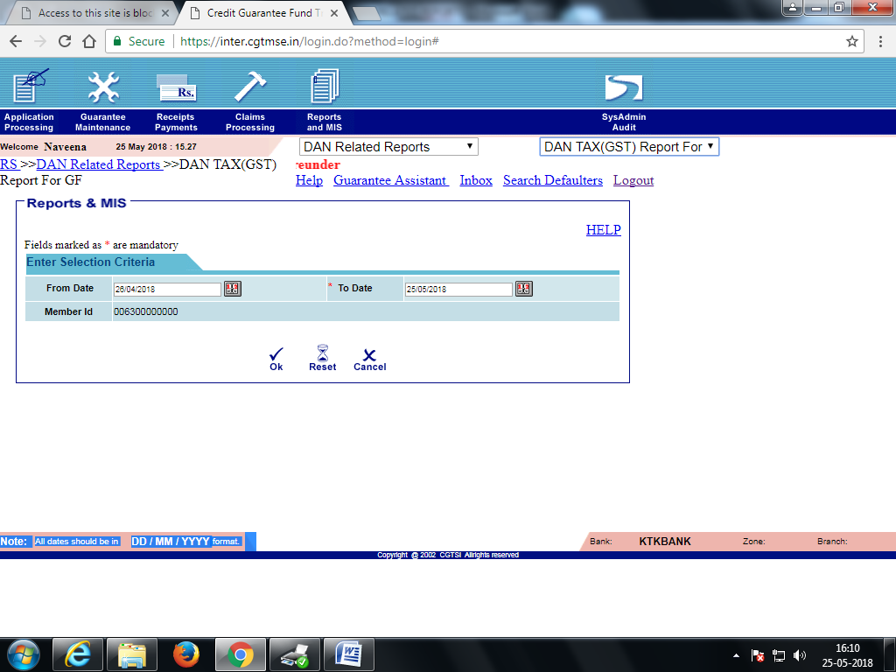

Figure 6.1.5‑2 : Allocate Payment Online

* After NEFT/ RTGS is completed, RPA shall download DAN related report for Guarantee Fund
* RPA shall send each DAN related report to respective branches via email

Refer Appendix Req# 13 for more details with screens of DAN related reports

# EXCEPTIONS

|  |  |  |
| --- | --- | --- |
| **#** | **Findings** | **Suggestions** |
| 1 | Currently all the data that in enter CGTMSE is filled referring documents share by each branch | S1: LAPS must share this data  S2: MIS shall provide the Account numbers  S3: Each Branch shall provide all the list, which is then consolidated and stored in local drive for RPA to Access |
| 2 | No of applications that need to be filled in the CTGMSE shall be based on no of documents received from the branch | S1: LAPS must share this data  S2: MIS shall provide the Account numbers  S3: Each Branch shall provide all the list, which is then consolidated and stored in local drive for RPA to Access |
| 3 | CGTMSE system, fields are accepted only in CAPS | S1:  RPA shall pick the data from the source item, and then convert to ALL CAPS and then entering into the CGTMSE System |
| 4 | Date entered should be DD/MM/YYYY | S1: RPA shall always choose the data picker  S2: if only text box then RPA shall enter in DD/MM/YYYY |
| 5 | Max limit for Term Loan & WC = 2 Cr, Term loan can be created n number of time not excluding 2 cr for a customer, for existing term loan CG PAN will be displayed as AP | S1: RPA shall check the customer details, Loan account and existing CG PAN before filling in the application to check amount not exceeding 2Cr |
| 6 | There can be possibility that loan can be approved twice for the same account (duplicate entry) in this case, system shall discard this duplicate entry and should provide request for closure, however this might be displayed in the screen for some time which needs consideration. | S1: Maintain a tracker for duplicate entries, so each time refer the record before selecting |
| 7 | Amount shall be debited from the loan account number and remitted to Virtual account through RTGS once payment is initiated | S1: Debit from various loan account belonging to a RP number (50 Account) to SLRTGS outward account from there RTGS to Virtual account |
| 8 | CGTMSE Site may go down (HTTP Status 500) | S1: If the Site goes down before and after submission, RPA shall check the application details> Status wise in the new. If the application is submitted it will be present if not present the RPA shall re fill and submit the data using Log reference or a tracker |
| 9 | CGPAN no for Existing TL, enhancement for WC, renewal of WC is not available in any system | S1: This should be made visible in LAPS or any system  S2: Maintain a tracker from which RPA can refer this data before filling in the application. |
| 10 | Interest rate is calculated (Contr Int. Rate -A/c pref. Int.(Dr.) =MCLR base rate | S1: RPA shall pick this data from Finacle against the customer |
| 11 | Maintain a register once the application is uploaded and approved | S1: RPA shall maintain a complete report of all application that are submitted, processed for payment and reported. |
| 12 | Last name is mandatory and system will not allow to enter blank details | S1: Enter “.” (dot) |
| 13 | For both TL and WC, 2 separate CG PAN will be generated after approval | S1: RPA shall maintain 2 records for a single customer with 2 separate CG PAN for TL and WC respectively |
| 14 | Finacle will not allow RTGS or NEFT for SLRTGS to Virtual account transfer after 4:30 PM | S1: RPA shall not conduct NEFT/RTGS transaction after 4:30 and shall maintain it for next day. Any transactions shall be reversed. |
|  |  |  |

# Application Access Requirements

| **Req#** | **Application** | **Permissions** | **Reference/Comments** |
| --- | --- | --- | --- |
| 1 | LAPS | Read | Required to get the information that need to be input for CGTMSE application filling |
| 2 | Finacle | Read | Required to get the information that need to be input for CGTMSE application filling |
| 3 | Local Drive | Read & Write | Read: Any information that need to be fill in manual in the CGTMSE application shall create and excel data which will be placed in the local drive for RPA to access and process it from there.  Write: Output from the CGTMSE application for the information will be saved in the local drive for future access |

# System Requirements

|  |  |  |
| --- | --- | --- |
| **Software Requirements** | **Operating System (Any one of these Operating System)** | * Windows 7 update [**KB 2533623**](https://goo.gl/x8hYZv) * Window 7 N update [**KB 968211**](https://goo.gl/Q7BfLX) * Windows 7 SP1 [**Update for Universal C Runtime**](https://goo.gl/YuVAP5) * Windows 8.1 * Windows 8.1 N Media Feature Pack [**KB 2835517**](https://goo.gl/Yu95L2) * Windows 10 * Windows 10 N Media Feature Pack [**KB4039813**](https://goo.gl/PWrVa7) * Windows Server 2008 R2 update [**KB 963697**](https://goo.gl/rGFVZ2) and the [**Desktop Experience**](https://goo.gl/L9MMYe) feature * Windows Server 2012 R2 Please note that **Windows Server 2012 R2 Standard and Datacenter** require the **Essential experience role**, [**Essentials Media Pack**](https://www.microsoft.com/en-us/download/details.aspx?id=40837), and lastly [**Update for Universal C Runtime**](https://goo.gl/YuVAP5) * Windows Server 2016 |
| **.NET Framework** | 4.5.2 |
| **Hardware Requirements** | **CPU** | 1.4GHz 32-bit (x86) |
| **RAM** | 4 GB |

# Appendix

| **Req#** | **Document** | **Reference attachment** |
| --- | --- | --- |
| 1 | CGTMSE Application Form - Detailed Requirements | <awaiting from LAPS team> |
| 2 | CGTMSE Guarantee Coverage Application format |  |
| 3 | CGTMSE-Procedures |  |
| 4 | Fresh Term Loan-Micro Service Enterprises |  |
| 5 | Existing Term Loan-Small Service Enterprises |  |
| 6 | Working Capital-Small Service Enterprises |  |
| 7 | Enhancement of Working Capital |  |
| 8 | Renewal of Working Capital |  |
| 9 | CGTMSE Loan Status Check |  |
| 10 | Allocate & Initiate Payment After Approval |  |
| 11 | NEFT&RTGS Loan Account Debit |  |
| 12 | LAPS source data | <awaiting from LAPS team> |
| 13 | Dan Related Reports |  |

# OUT OF SCOPE

* Additional Term loan, RSF2 for Working Capital, RSF2 for Term Loan, RSF2 for TL & WC application filling.

# FUTURE SCOPE

* All the scoped application form data shall be available in LAPS, and RPA to pick all the data only from LAPS.
* CGTMSE NPA application filling and updating
* ASF Payment through NEFT/RTGS is done yearly in the month (there are 6 processes within it)

# ASSUMPTIONS

* Specific User IDs will be created to be used with the robot to login into all the required applications as listed in section 8

# Risks & Mitigation

* All data is not available in LAPS - As a temporary solutions branch has to fill the data in an excel sheet and this sheet will be placed in a local drive, and RPA shall pick from this location

# CLIENT ACCEPTANCE

|  |  |
| --- | --- |
| Name of Document |  |
| Document |  |
| Revision Number |  |
| Number of Pages |  |
| Date Prepared |  |

This document has been approved as the official Functional Requirements Document for RPA of CGTMSE - Online Application and Processing, and accurately reflects the current understanding of business requirements. Following approval of this document, requirement changes will be governed by the project’s change management process, including impact analysis, appropriate reviews and approvals

If you are in agreement with the above Business Requirements document for the mentioned business process automation, please sign below with date and return it back to Shamaprasad C. G(shamaprasadcg@novigosolutions.com) via email to confirm.

Karnataka Bank Pvt Ltd Novigo Solutions Pvt Ltd

|  |  |  |  |  |  |  |  |  |  |
| --- | --- | --- | --- | --- | --- | --- | --- | --- | --- |
| |  |  | | --- | --- | | Signature:______________________________ | Signature:_____________________________ | | Name: | Name: Shamaprasad C. G | | Job Title: | Job Title: Project Manager | | Date: | Date: | |  |